

**Date: 12 October 2020 / Reg. № 00044**

**To Whom It May Concern:**

Dear Sir/Madam,

**DA LAB Foundation** in partnership with **Sofia Municipality** is pleased to present you the opportunities for collaboration within the borders of ‘One Person – Electronic Body in Urban Environment’ project.

The project is launched as part of the Outside program of Sofia Municipality for temporary works of art in urban environment. The first issue of the program was held last year in through an open call when the high-tech interactive installation **One Person** created by **Venelin Shurelov** was chosen as one of the selected projects. The Outside program of Sofia Municipality financially supports the One Person project with 81 100 BGN. The installation started in the middle of September and the official opening is about to be held in the middle of October 2020. The project will last for a year.

The realization of this technological work of art inevitably challenges us with hurdles that we cannot overcome without the significant support of our partners. The funds provided by Sofia Municipality cannot fully cover all the activities that One Person with its precedence requires. In order to develop its potential, we need additional financial and material support, as well as more reliable partners with whom we can grow together.

We recognize such an important and invested partner in the profile of Your company and we hope you and Your team will also share our views. We believe that One Person project will be attractive to you, as it is a suitable platform for direct and clear statement of the values and understandings You communicate with Your clients. Thanks to the possibilities that this platform enables you to explore, Your message will engage young and aware audience with active position and bold vision. Your contribution will be a proclamation to the general public for Your care and affinity in providing much-needed support for the cultural and social life of the country in these turbulent times.

Our specific proposals for cooperation are described in the attached file with sponsorship packages. The options listed there will give you the opportunity for a broader reach to nationally and internationally represented communities of people from the social spheres of culture and technology. In addition, this will grant You the opportunity to be a part of the ever evolving events in the country and the growth of the region. The One Person project has acquired a sustainable and diverse media platform through which You can communicate with the audience firsthand.

**THE PROJECT:** The installation will be positioned at the famous site "Mausoleum" located at the Knyaz Alexander I Square, Sofia. A new city symbol will appear in this sensitive and emblematic area of ​​the city's history. It is a 13-meter construction that resembles a human figure covered with 42 LED displays emitting dynamic visual content generated by a specially designed computer algorithm. The figure that will inhabit the public space is not a specific historical figure, but a collection of a constantly updated set of passers-by or deliberate visitors. The electronic body will combine video magnifiers from CCTV cameras located around it, generative visualizations and text. The installation One Person falls into the category of process-oriented art. The work is separated from the total control of the author and is a flexible structure that depends on human behavior and environmental change. Modern technologies make it possible to build systems with open access, with a liberal rather than authoritarian way of functioning. The object built on this principle would be a good reflection of our collective image at the moment.

The work of art itself with its modern, technological and innovative implementation is a testimony of the modern cultural policy of the city. We should follow the development of One Person in order to observe its conclusions from the great equation of the city and its people. Be part of this process!

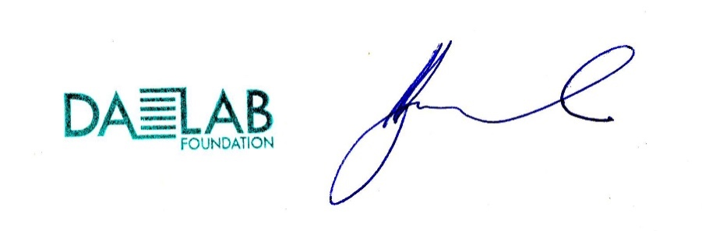In addition to the proposals described in the sponsorship packages, we remain open for dialogue regarding other options for cooperation related to the Project.

I am looking forward to Your answer.

Yours Faithfully,

Assoc. Prof. PhD Venelin Shurelov,

Creator of the One Person project

Manager, DA LAB Foundation

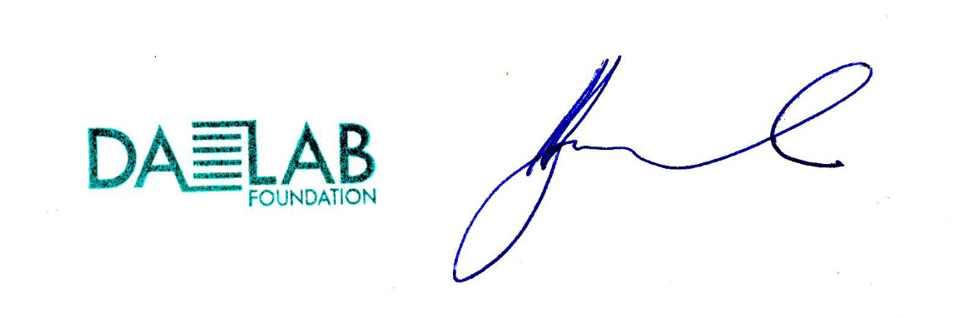

+359898260543

[shurelov@nha.bg](mailto:shurelov@nha.bg)